Tabari Harvey Module 5.2 Assignment

1. Count function is used to return the number of records returned by the selected query. You can count how many employees or products there are.

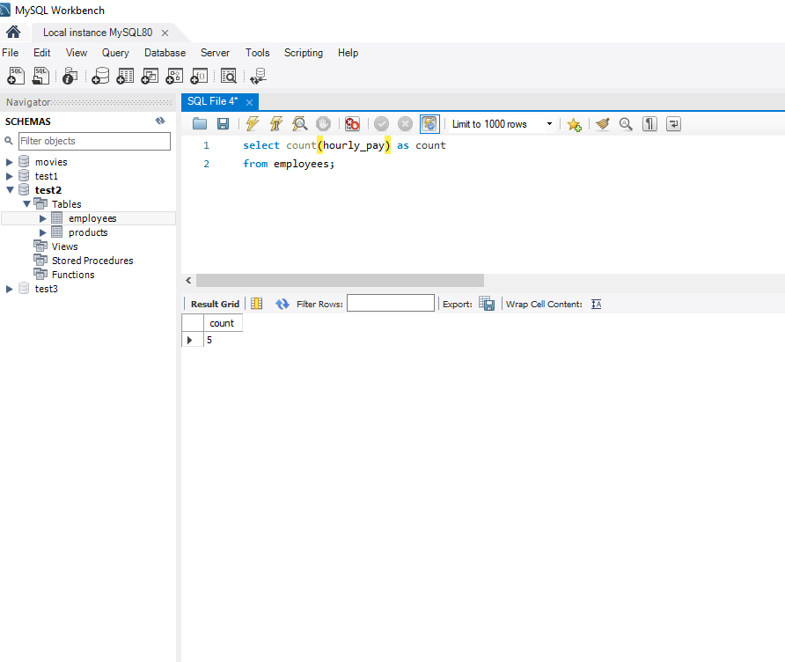

1. Max function will return the maximum value in a set of values. You can add up how much total the employees make all together.

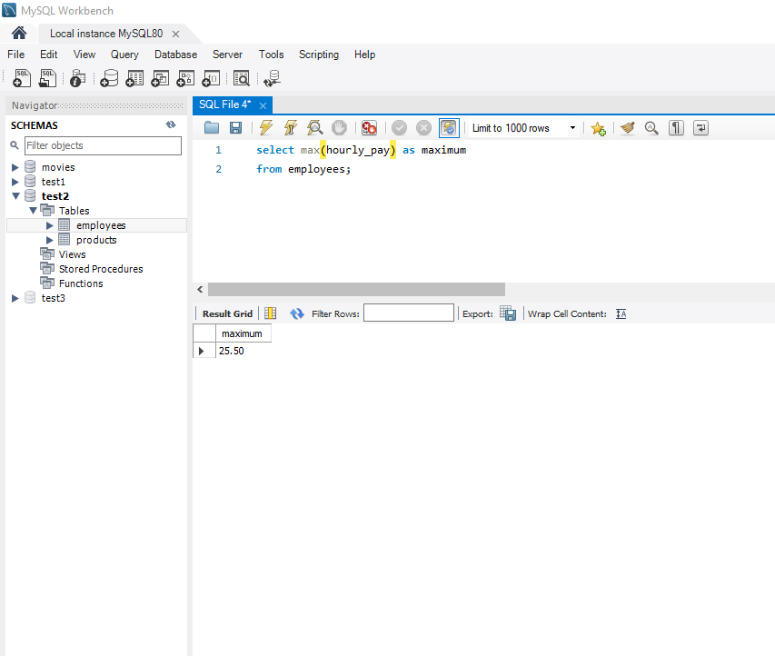

1. Min is a function that returns the minimum value in a set of values. You can find the price of the cheapest product or employee who makes the least amount per hours/salary.

